**DAILY ONLINE ACTIVITIES SUMMARY**

|  |  |  |  |  |  |  |  |  |
| --- | --- | --- | --- | --- | --- | --- | --- | --- |
| **Date:** | **24/06/2020** | | | | | **Name:** | **Likhitha.M** | |
| **Sem & Sec** | **6th sem & A sec** | | | | | **USN:** | **4AL17CS046** | |
| **Online Test Summary** | | | | | | | | |
| **Subject** | | **-** | | | | | | |
| **Max. Marks** | | **-** | | **Score** | | | **-** | |
| **Pre-Placement Training Summary** | | | | | | | | |
| **Pre placement training** | **9:00 am to 11:00 am - Programming in Java**  **11:00 am to 1:00pm - Datastructures in C** | | | | | | | |
| **Faculty** | | | **Ms.Shilpa**  **Mr.Venkatesh Bhat** | | **Duration** | | | **4 hr** |
| **Assessments** | | | | | | | | |
| C program to sort a stack in ascending order using temporary stack. | | | | | | | | |
| **Status: Completed** | | | | | | | | |
| **Uploaded the report in Github** | | | | | **Yes** | | | |
| **If yes Repository name** | | | | | [**https://github.com/likhithaMantaral/Daily-status**](https://github.com/likhithaMantaral/Daily-status) | | | |
| **Uploaded the report in slack** | | | | | **Yes** | | | |

**Training snapshots:**

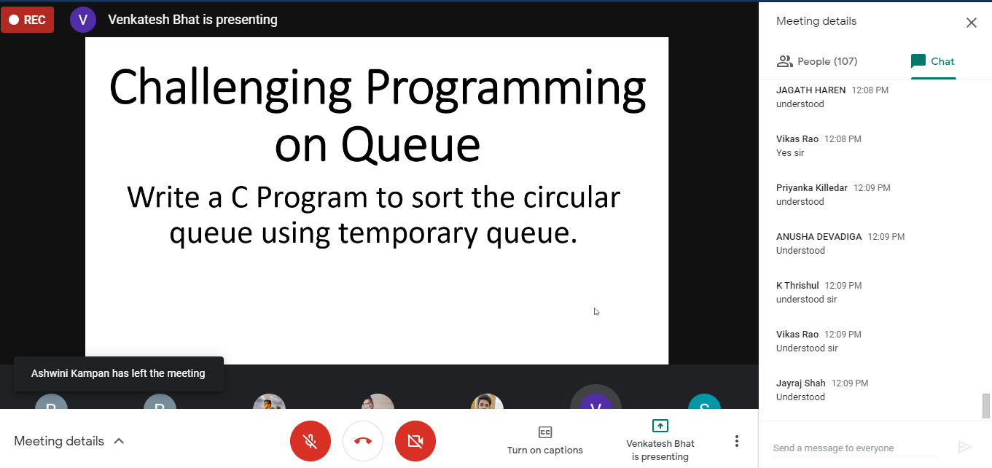

**Assessments:**

**The assessment is uploaded in github repository and the link is given below:**

[**https://github.com/likhithaMantaral/Pre-Placement-Training**](https://github.com/likhithaMantaral/Pre-Placement-Training)